Name: __________________________________ Date: ______________
CLG 1.1.4 The student will describe the graph of a non-linear function in terms o the basic concepts of maximum and minimum, roots, limits, rate of change, and continuity
1. Look at the function that is graphed below.
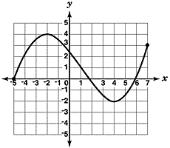
What is the range of this function?

- −5 ≤ y ≤ 7
- −5 ≤ y ≤ 3
- −2 ≤ y ≤ 3
- −2 ≤ y ≤ 4

2. Look at the function that is graphed below.
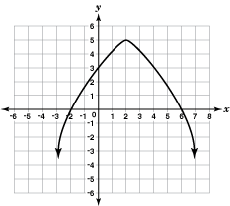
What is the maximum value of this function?

- 2
- 3
- 5
- 6

3. Which function graphed below is not continuous?

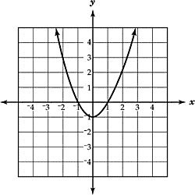
B
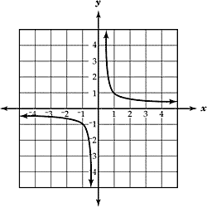
C
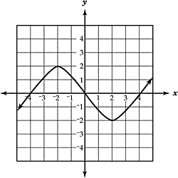
D
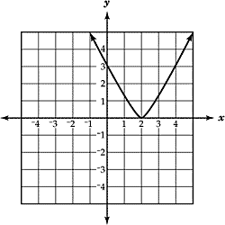

4. Which of these graphs shows a function that is not continuous at x = 2?

- 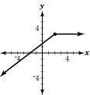
- 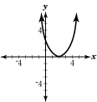
- 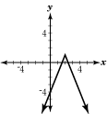
- 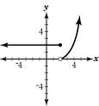

5. Look at the function that is graphed below.
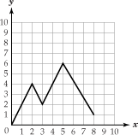
What is the domain of this function?

- 0 ≤ x ≤ 5
- 0 ≤ x ≤ 8
- 0 ≤ y ≤ 1
- 0 ≤ y ≤ 6

6. Look at the function that is graphed below.
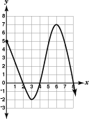
What is the maximum value of this function?

- 5
- 6
- 7
- 8

7. Look at the function that is graphed below.
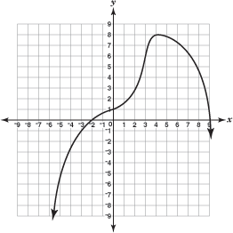
What is the maximum value of this function?

 | A | -2
 | B | 1
 | C | 8
 | D | 9

